Task 4: Sequential Commits, Reset & Rebase
- Enhancing the To-Do Form in master_1: Add the following fields to the To-Do form: Item ID, Item UUID, Item Hash.
- Committing in Sequence: Add and commit each field separately — first commit: Item ID; second commit: Item UUID; third commit: Item Hash.
- Merging to main: Merge the master_1 branch into the main branch.
- Git Reset: In the main branch, roll back to the commit where only the Item ID field was added. Use git reset --soft to ensure changes remain staged, then re-commit this state and merge it to main.
- Rebasing: Rebase the updated main branch changes onto master_1 using git rebase main master_1. Preserve individual commits (do NOT squash) to maintain commit history.
Added the Item ID Field :
git diff : used to check the new changes
git status : list the modified files
git add : to add modefied file to staged
git commit : to save the staged changes
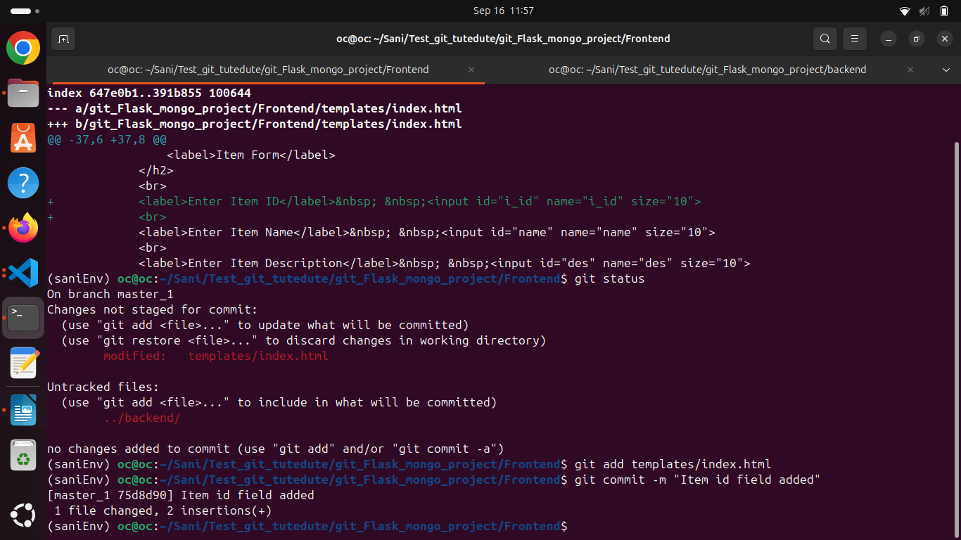
Added the Item UUID field
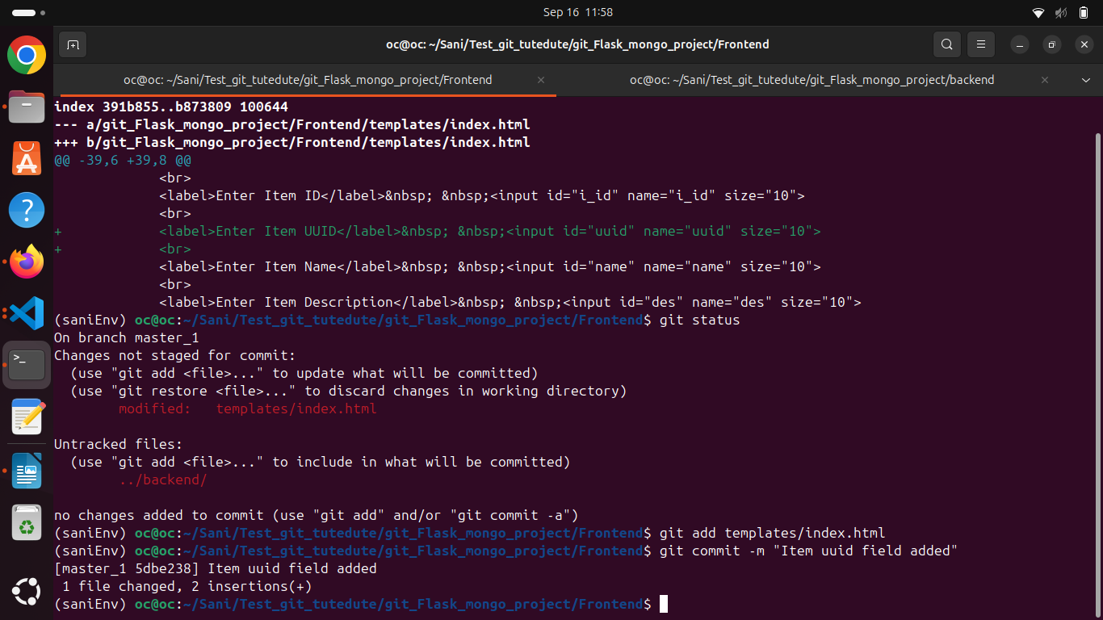
added the Item Hash field
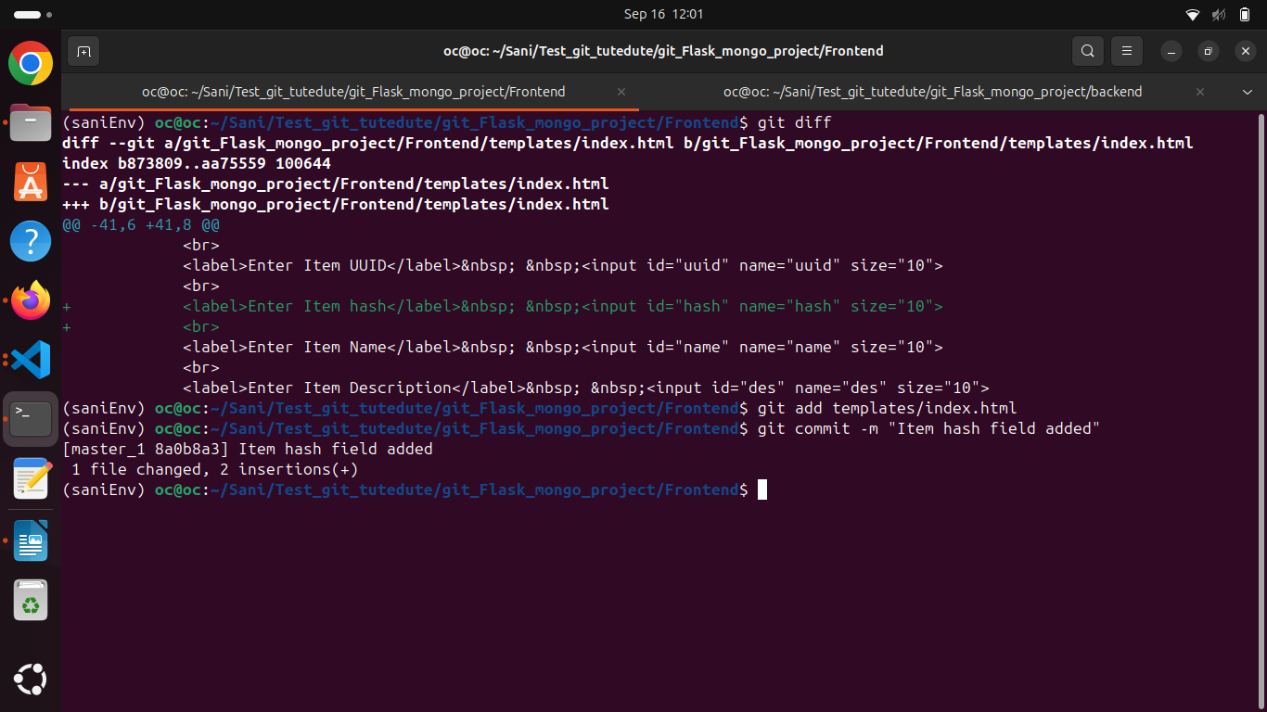

merging this to main branch:
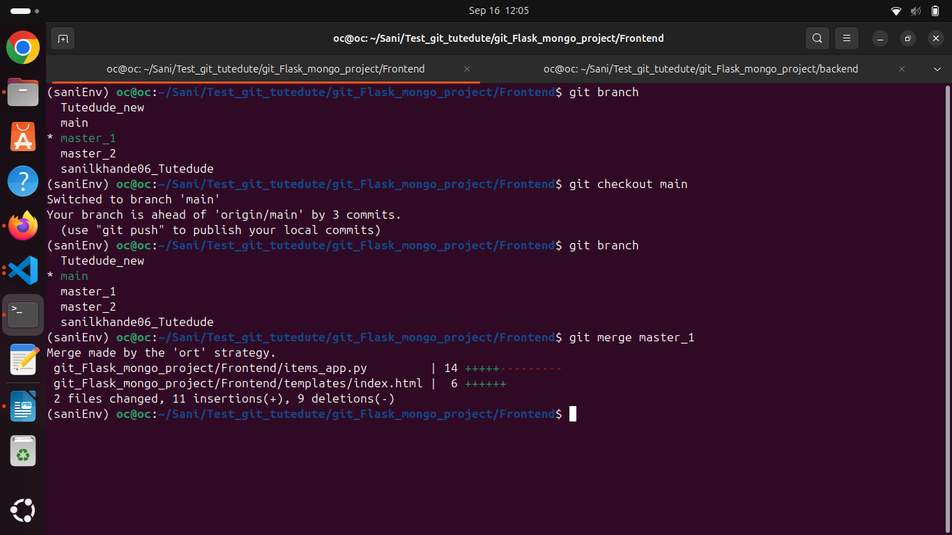
New form :
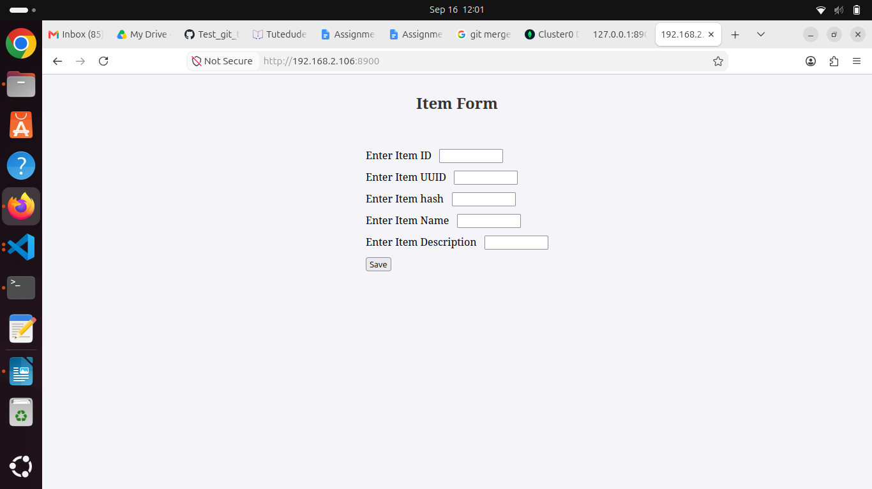

backed modified to adapt the new changes :
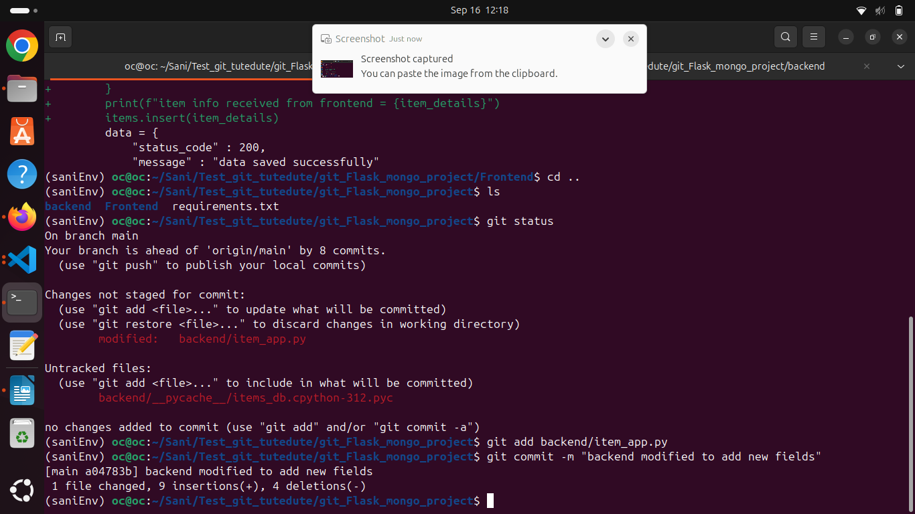

git log to check the current head and older commits:
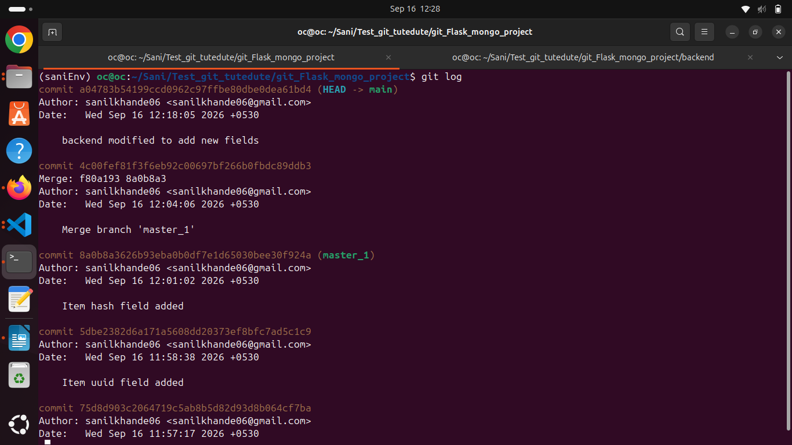

git reset - - soft “commit id”
git reset is used to go back the old commit - - soft is used to keep the changes and commits.
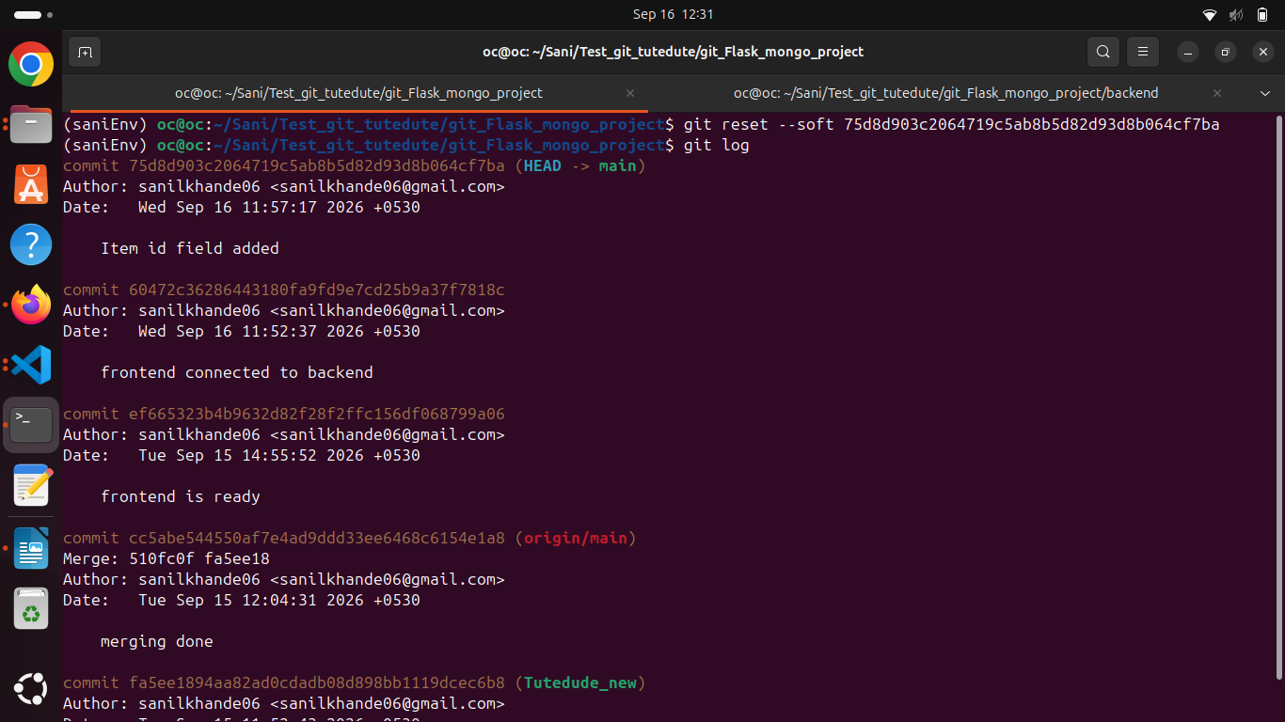
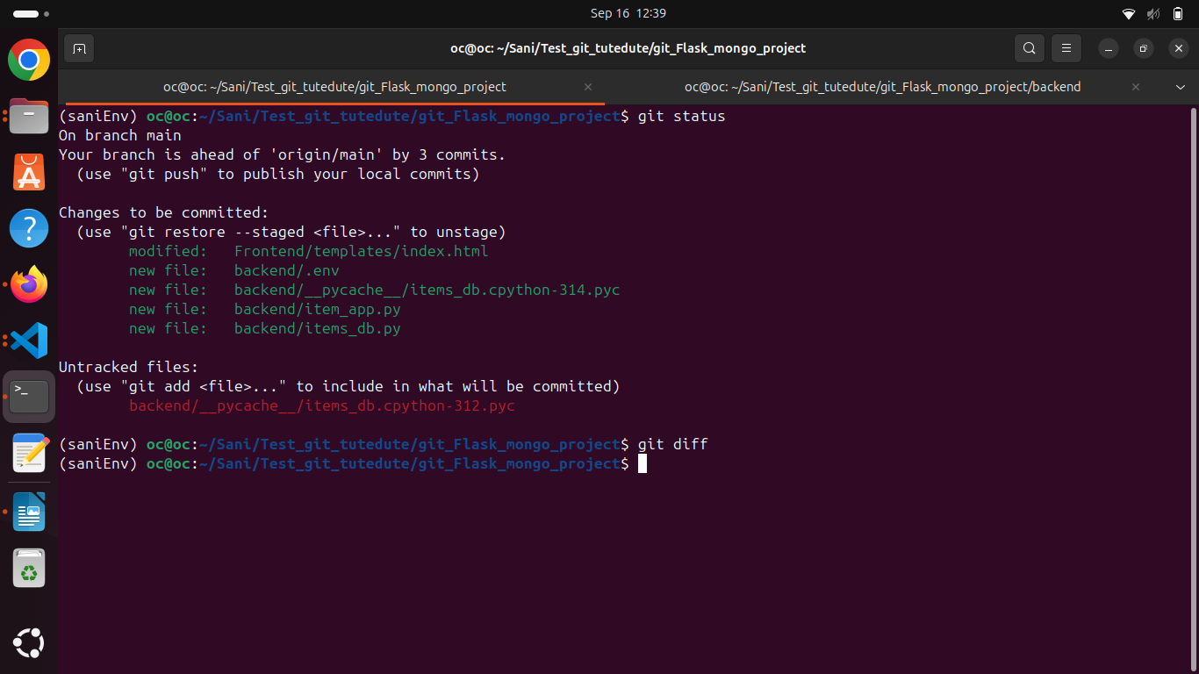

Commiting the changes with new commit :
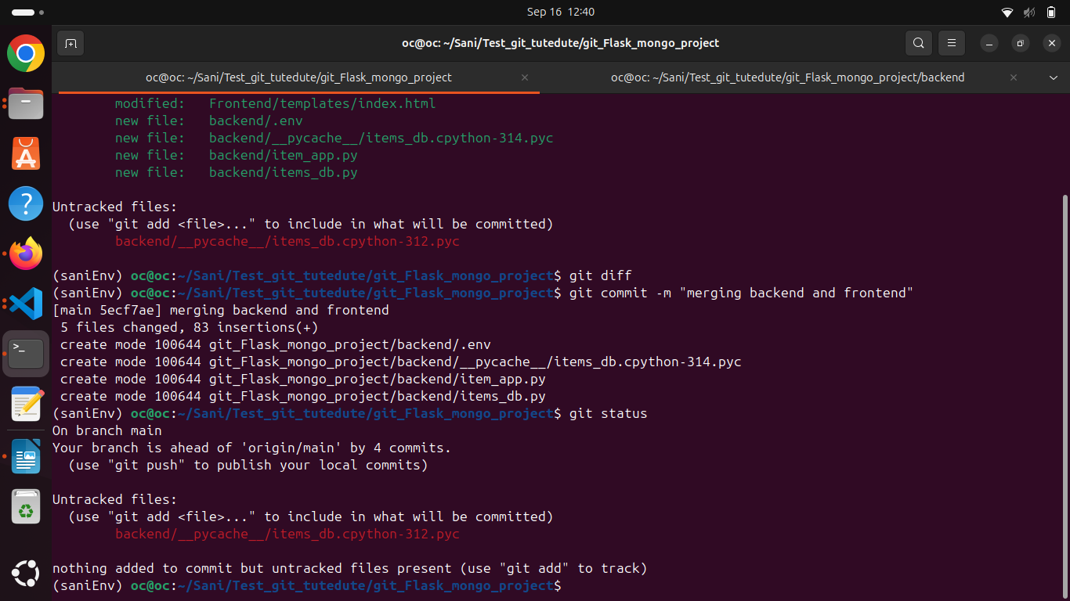

rebase the changes to master_1 . Got the merge conflict so resolving by accepting the incoming changes.
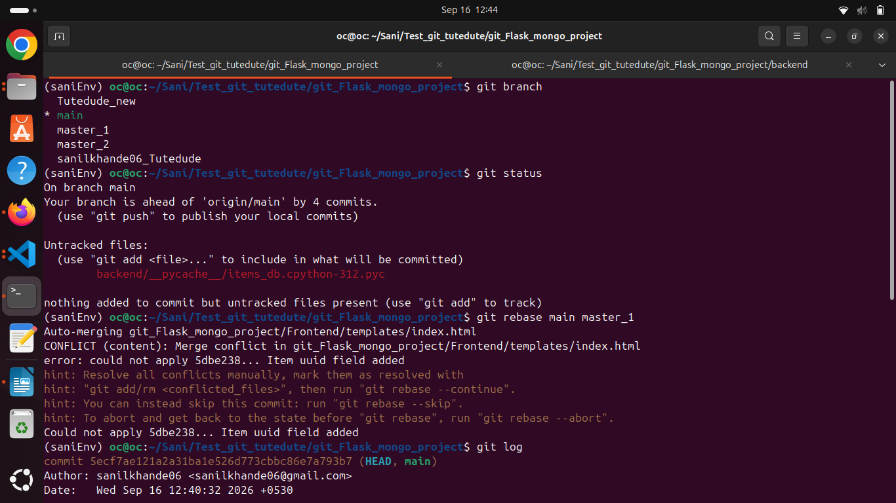

commited the all changes to master by resolving one by one commit changes
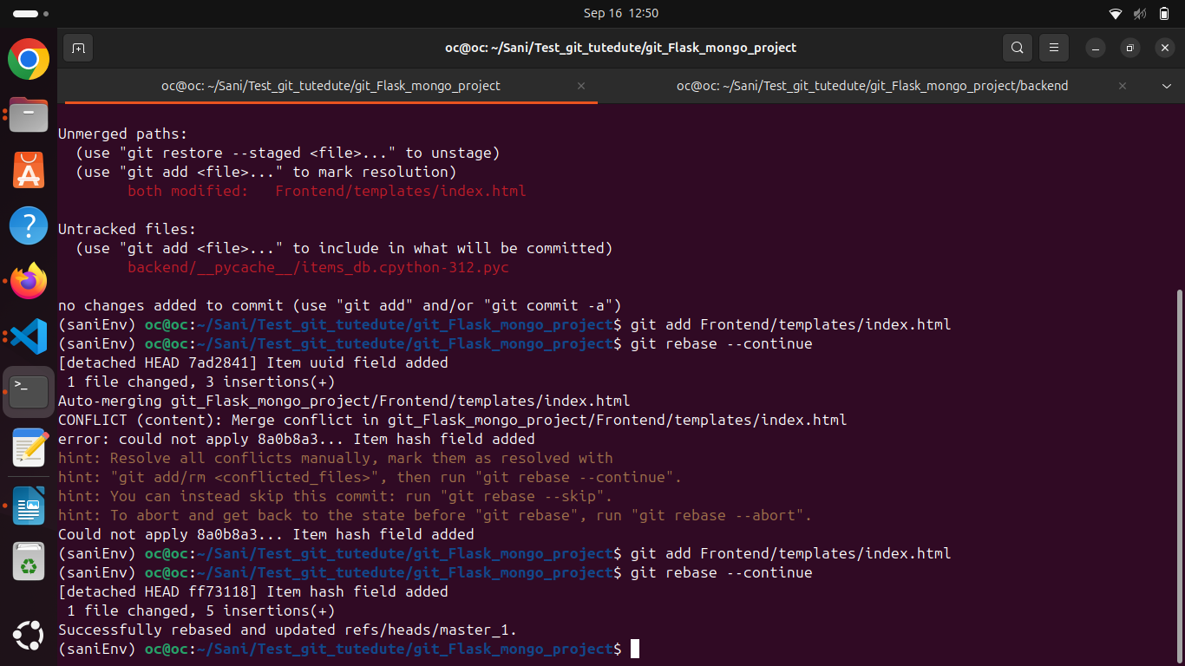
running the application :

